H.264 -1080P remote wireless hidden camera

Thank you for purchasing this product, the machine uses a unique ultra-portable design, it can be applied in various fields, it is very convenient, safe and bring a colorful life for you, please set your camera correctly in accordance with the guidelines of the quick steps .

I：the key indicator of the state represented by the model
5P USB data cable to connect the power head or charging head, mobile power can boot directly, or red with black plug connected to the power supply can be used simultaneously.
Blue light is the power indicator, power has been lit, red LED is WIFI
Specific models are as follows：
1. Ad hoc mode: Slow red flashing 2. Router mode: red light flash
3 After you have configured remote camera: red light
Under clear what mode, the camera can be reset at switch to point mode.
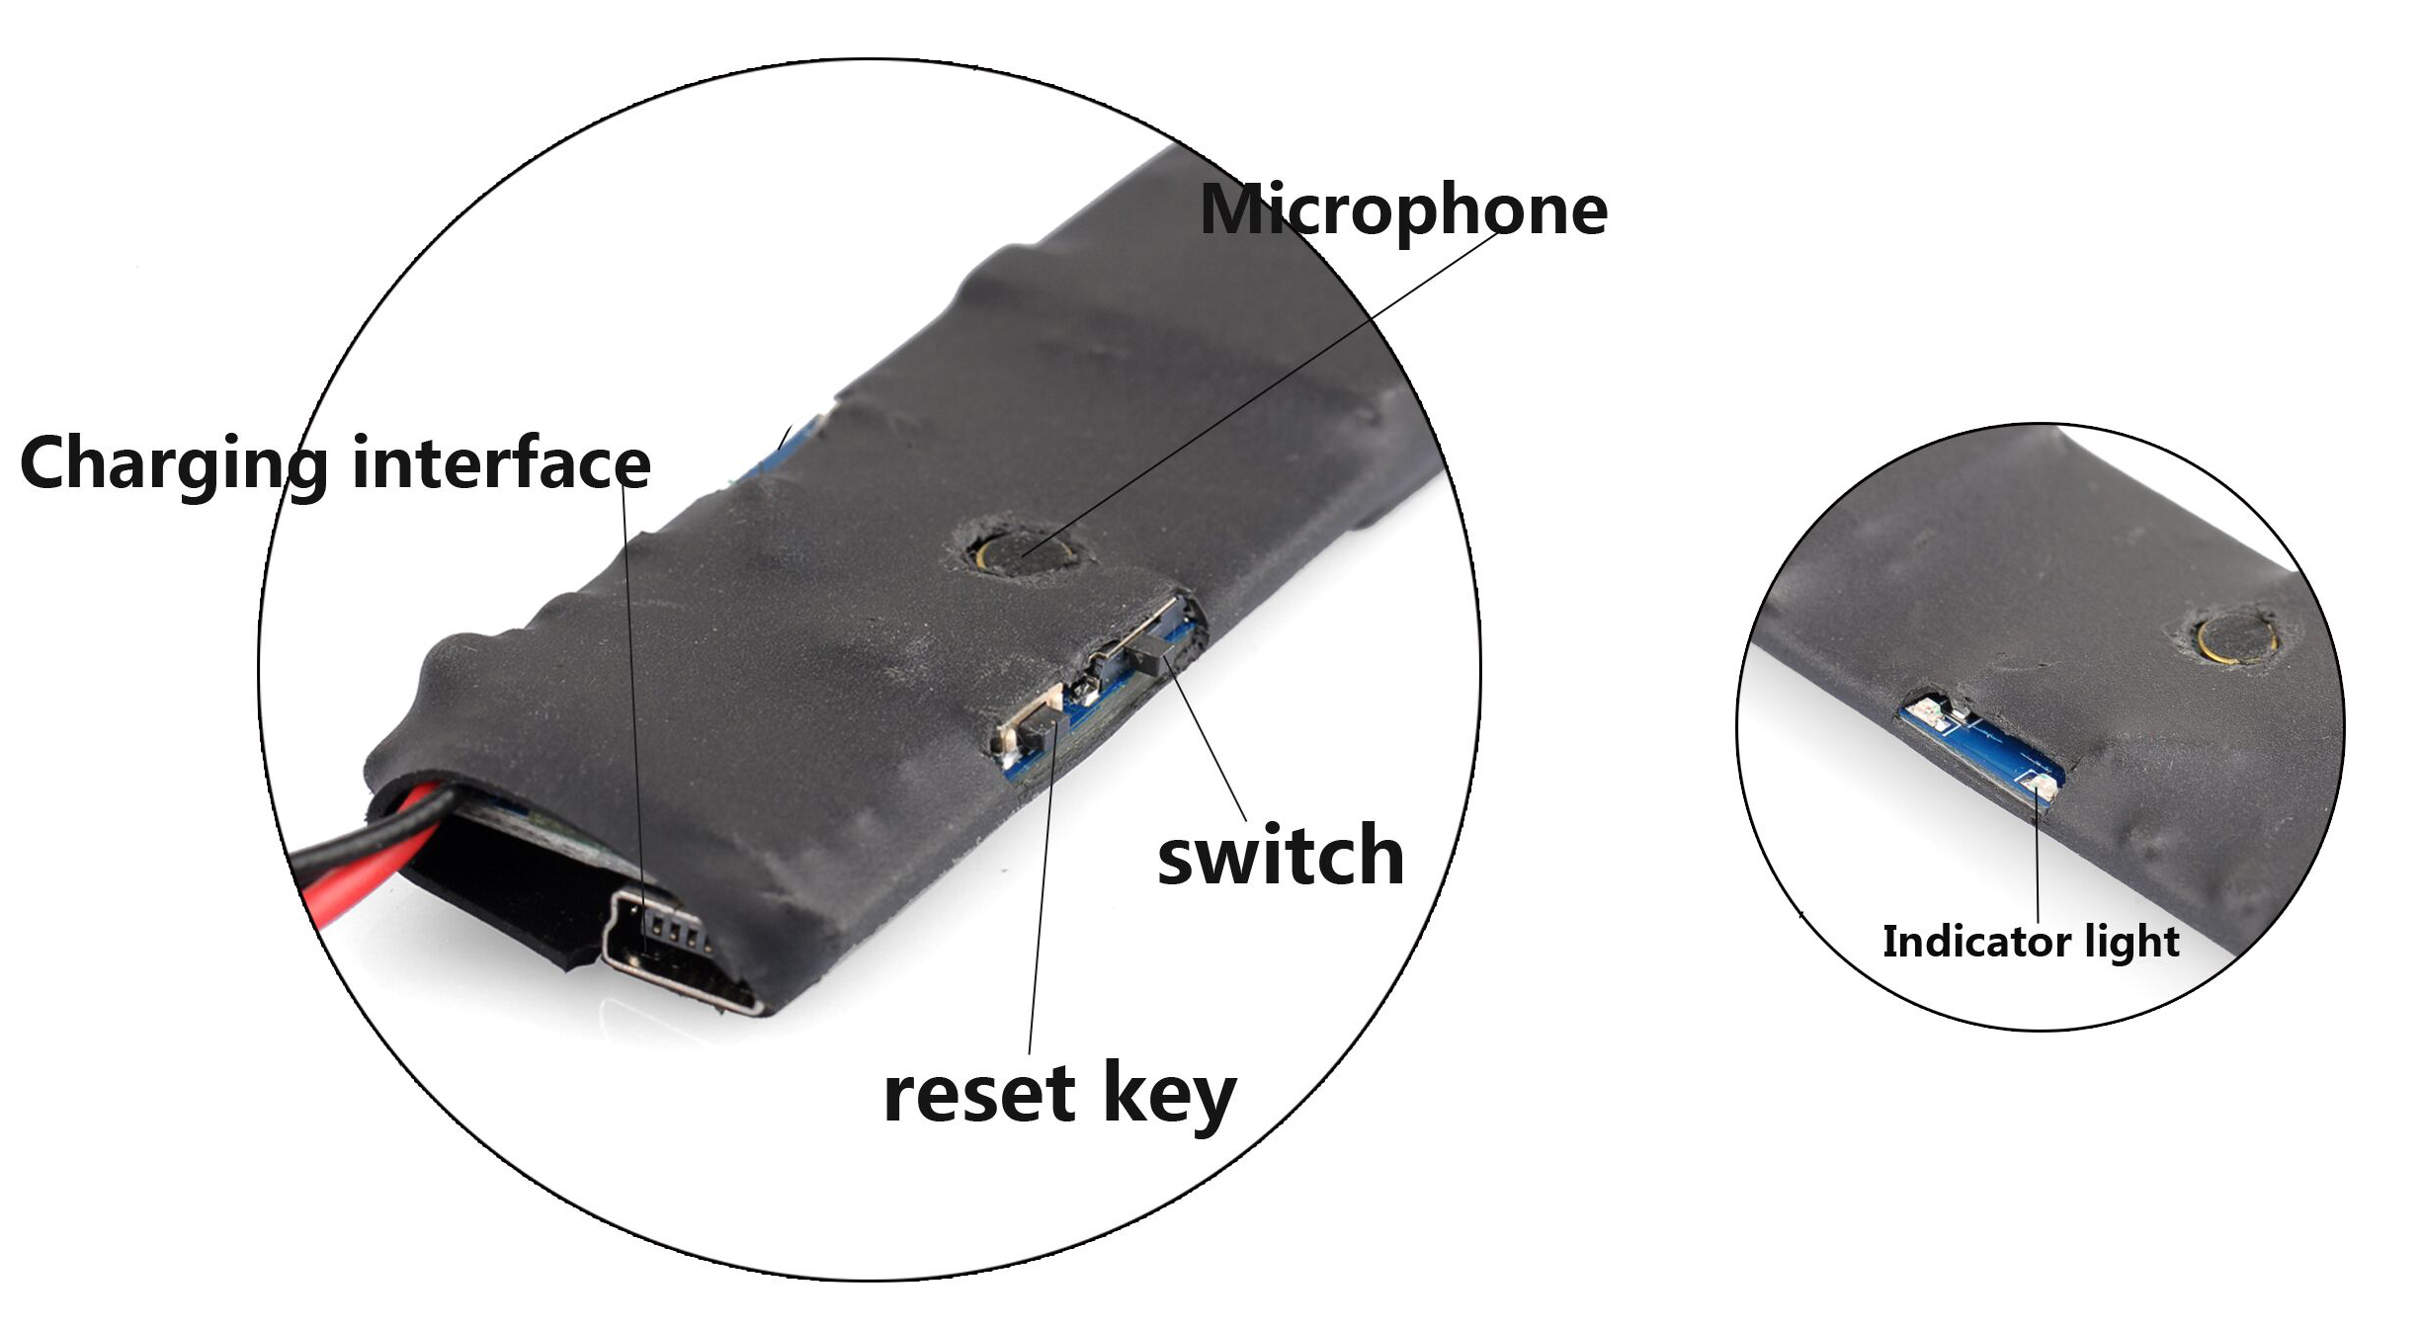
Note: This must be reset at a red light flash or slow flash when you press the reset built to be useful! Press the reset built around five seconds off the whole machine lights let go until the camera starts to complete (about 30 seconds).
II、APP software download
 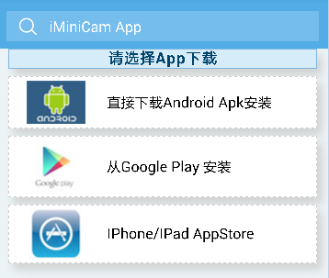
（图1） （图2）
Method 1. Scan the QR (picture 1) code directly to go to the download screen (picture 2). Select appropriate download software according to your mobile phone system. (Note: 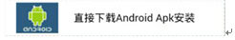. This kind of installation is only available for Chinese Mainland).
Method 2: For Android phones, search for APP software named “iminicam” in Google Play, download and install it.
For Iphone, APP software named “iminicam” in App Store, download and install it.


III、Point the camera phone connection
Enter the phone settings where WIFI signal inside, find the signal (this is the machine UID number is unique to each machine) and connected. as the picture shows
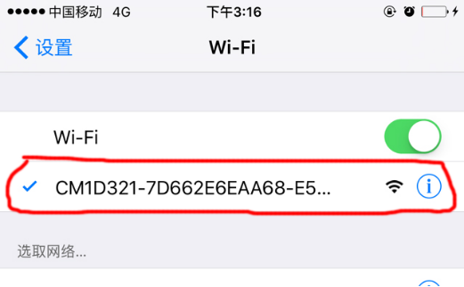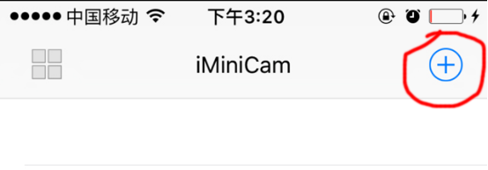
Then open the phone APP (IMINICAM) appears as shown in the figure, this signal is the machine's UID UID of each machine is different, even after clicking on the plus sign shown above to add into the camera as shown below.
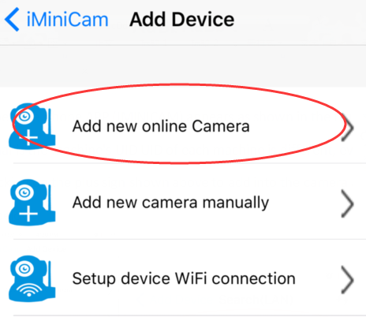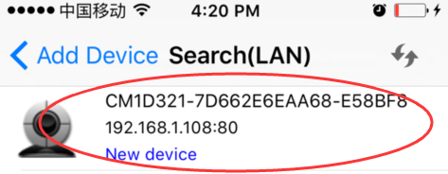

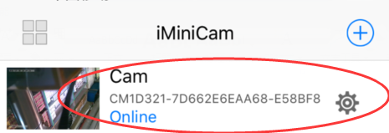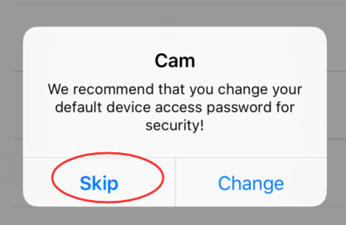

Click to go online camera appears as shown, click Skip to watch videos.

IV、Camera remote settings

In point can watch video, return to the previous enter the interface shown
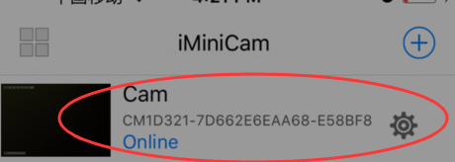
Click on the small gearEnter Advanced configuration shown below
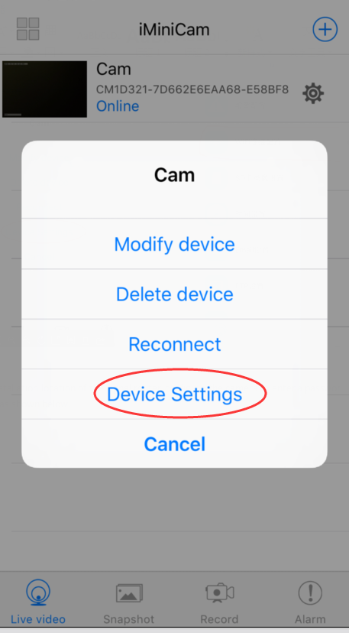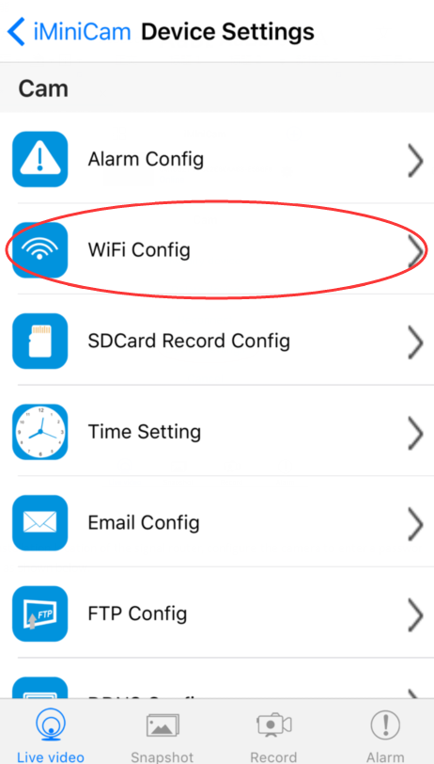

Find the installation location of the signal router, configure the camera to enter a password into the router as shown below.
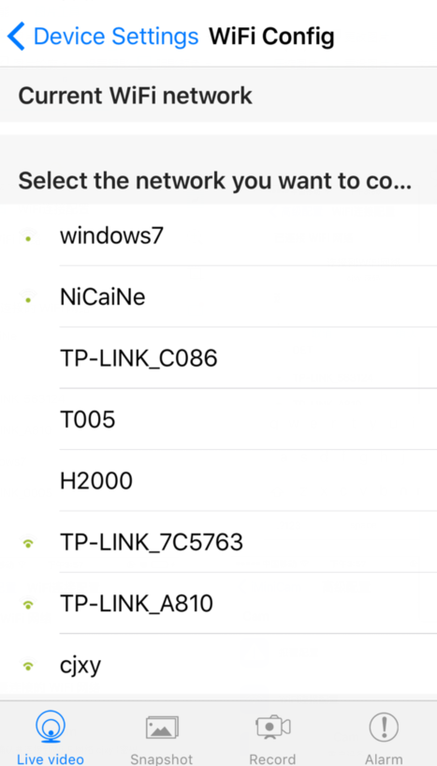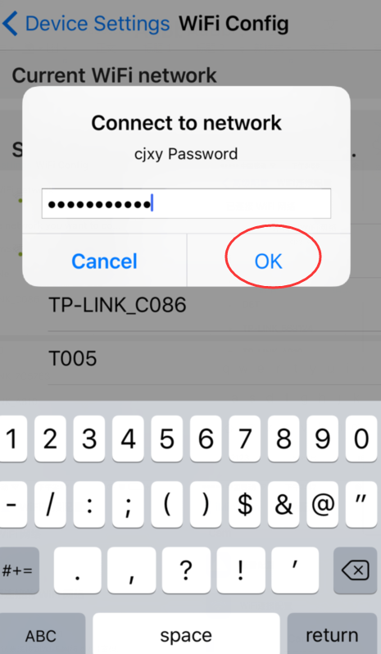
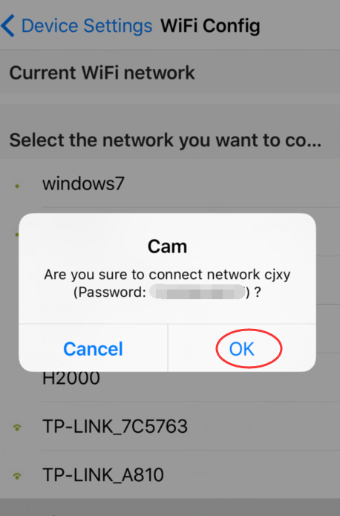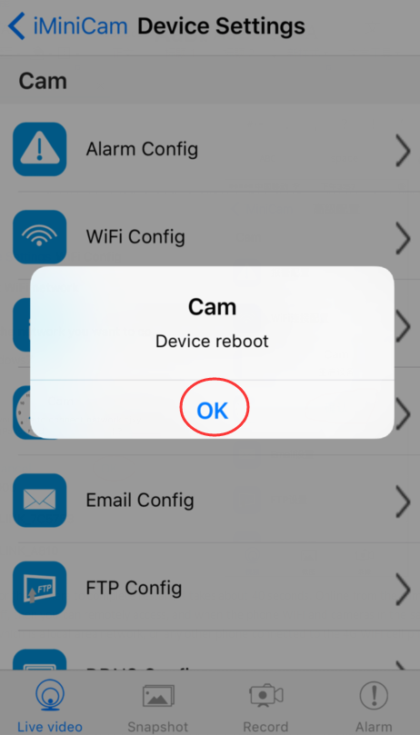
OK, wait for the camera to complete restart, it takes about 40 seconds. Online from the camera will turn off, then you can remotely access, and when the phone WIFI and cameras in the same network which is a local area network, or any other phone connected to the 4G WIFI cell phone signal APP will automatically reconnect the camera after a successful connection You can watch the video.
V.LAN view the picture on the page
Open cd diskEnter 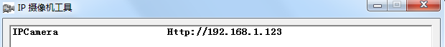
Enter
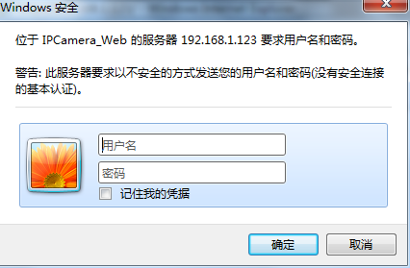
name：admin Enter
Initial use must first download a plug
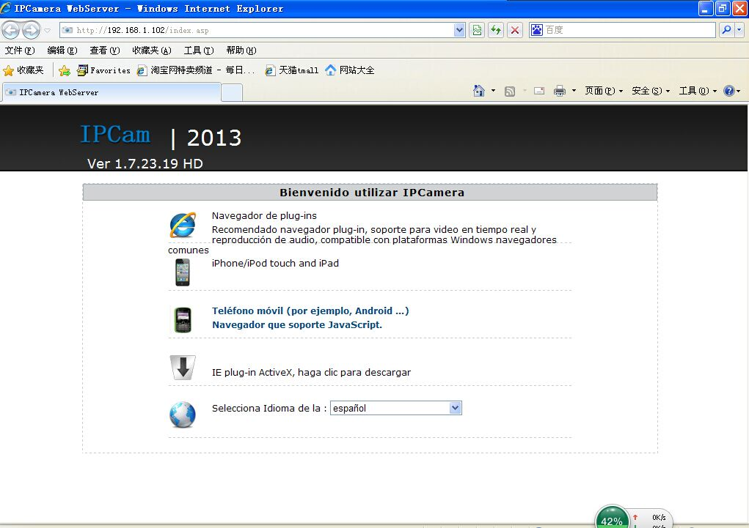
Enter 

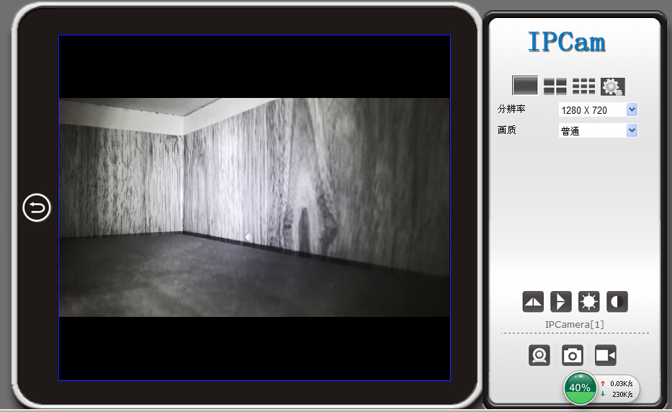

Enter
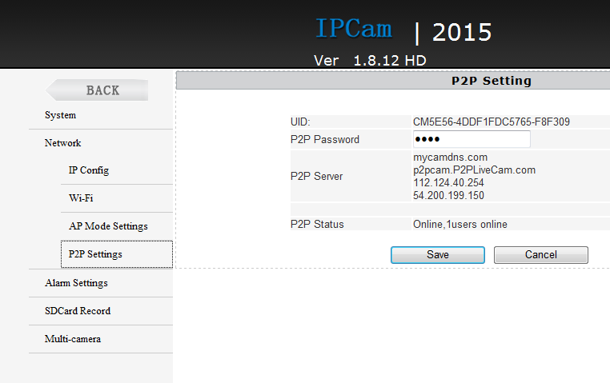
Here P2P configuration of the machine can be seen opening the UID and password (default 8888) where you can modify the camera's password.

VI.computer client access settings

1）. Insert the CD-ROM in the client tools installed on the computer side.
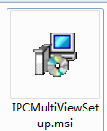
2）. Click on the successful installation will appear as shown in Figure Desktop login box appears. (See below)
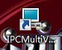
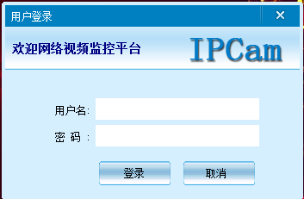
Enter the user name (admin) Click login (Note: The original user name is admin without a password).
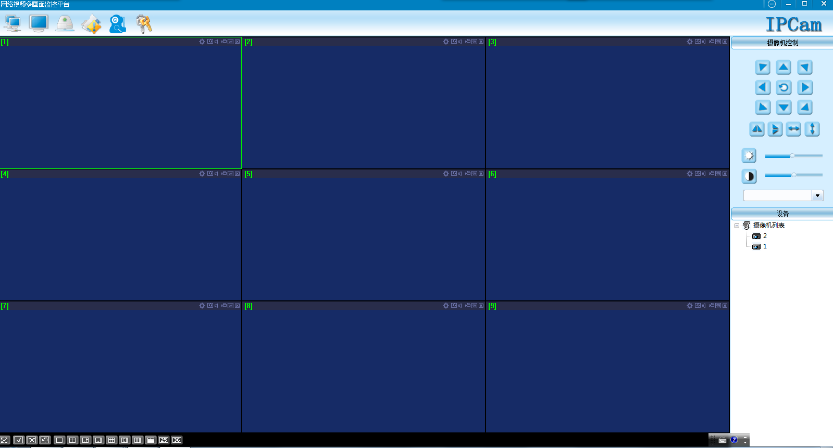
Enter
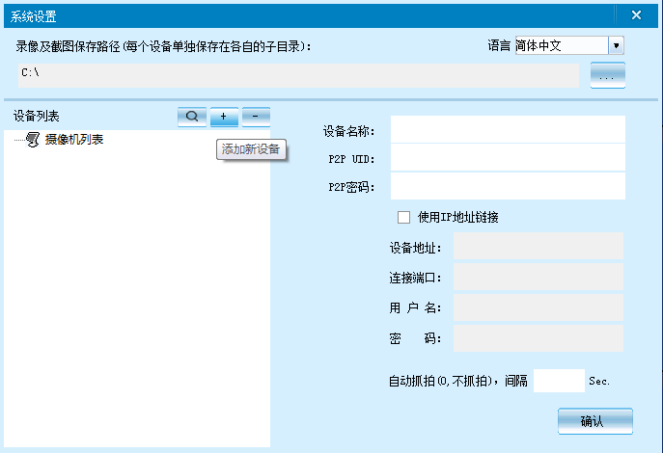
Enter 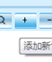
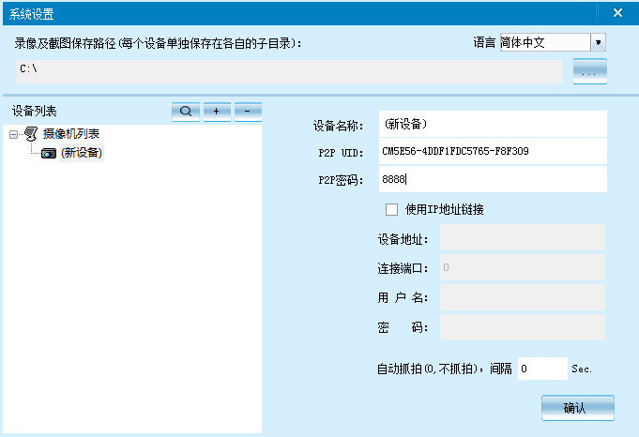
Enter  Enter 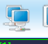

Note:
The device name easy to remember just write
Paste on P2P UID
Password had not been changed, then that is 8888 if you have modified, please fill in the date.
Note:
The device name easy to remember just write
Paste on P2P UID
Password had not been changed, then that is 8888 if you have modified, please fill in the date.
7. Specifications

Pixel | 1200 Mega CMOS
Resolution Ratio | 1080P/720P/640P/320P
Video Format | ASF
Frame Number | 25
Visual Angle | 90 degree
Motion Detection Camera Shooting | Straight line 6 meters
Minimal Illumination | 1LUX
Battery Capacity | 4000MA
Video Duration | Over 5 Hours
Compressed Format | H.264
Recording Range | 5㎡
Consumption | 240MA/3.7V
Storage Temperature | -20-80 degree centigrade
Operating Temperature | -10-60 degree centigrade
Operation Humidity | 15-85%RH
Memory Card Type | TF card
Maximum capacity of memory card | 64GB
Player Software | VLCPlayer/SMPlayer
Computer Operating System | Windows/Mac OS X
Mobile Phone Operating System | Android/iOS
Web browser | IE7 and above,chrome,firefox safari.etc
窗体顶端  Largest customer | 4

8.FAQ

- Why remote monitoring is not smooth?
You should choose suitable resolution to watch according to your Internet.
- Why SD card cannot save?
SD card must be formatted if this is your first time to use.
- Why Connection is not on the network?
Select the correct connection way according to your network
- Why APP remote viewing SD card video is not smooth?
As a result of the mobile decoding ability are different, and you can adjust video equipment according to your mobile’s resolution
- How to find my password?
To press reset key with 10 seconds and Restore the factory Settings.

Note:
The device name easy to remember just write
Paste on P2P UID
Password had not been changed, then that is 8888 if you have modified, please fill in the date.
Special note:
1. If the camera is not connected to the router, please reset, even after a hot machine to configure.
2. If the camera does not read the memory card, or mobile phone in the LAN advanced settings in the background formatting after use.
3. Shutdown Reset: Please re-operation off and reset when you see the red light.
4. To play a video file on your computer, please use the disc in the player vlc_play software.

